**PROJET REPORT**

**ON**

**A STUDY OF GOODS & SERVICE TAX & E –FILLING OF GOODS ANS & SERVICE TAX**

**SUBMITTED TO**

**KCE Society’s Institute of Management & Research, Jalgaon 425001**

**IN PARTIAL FULFILLMENT OF REQUIREMENT FOR**

**THE AWARD OF THE DEGREE OF**

**MASTER IN BUSINESS ADMINISTRATION (M.B.A)**

**FINANCE**

**SUBMITTED BY**

**MR.GANESH RAJU NIKUMBHE**

**MBA (Batch-2020-2022)**

**UNDER THE GUIDANCE OF**

**PROF. JAYASHREE CHAUDHARI**

**Index**

|  |  |  |
| --- | --- | --- |
| **Chapter No.** | **Content** | **Page No.** |
| **1** | **Introduction** |  |
| **2** | **Literature Review** |  |
| **3** | **Objective & Scope of the project** |  |
| **4** | **Research Methodology** |  |
| **5** | **Theoretical Background** |  |
| **6** | **Data Analysis** |  |
| **7** | **Conclusion** |  |
| **8** | **Findings** |  |
| **9** | **Suggestions/Recommendations** |  |
| **10** | **Bibliography** |  |
| **11** | **Annexure** |  |

**List of tables**

|  |  |
| --- | --- |
| **Table No** | **Table Name** |
| **1.1** | **The structure of Indirect Tax levy** |
| **1.2** | **Multi stage of Supply Chain** |
| **1.3** | **History of GST** |
| **1.4** | **The tax structure under the new regime** |
| **1.5** | **GSTR-3b Filing** |
| **1.6** | **GSTR-1 Filing** |
| **1.7** | **Month wise tax collection Excluding IGST paid on Import of goods** |
| **1.8** | **Financial year wise Comparison E way bills generated & Asset value in cr.** |
| **1.9** | **Major head wise collection excluding IGST paid on import of goods** |

**INTRODUCTION**

**Introduction**

GST is known as the Goods and Services Tax. Goods and Services Tax (GST) is an indirect taxation in India merging

most of the existing indirect taxes into single system of taxation. It was

introduced as The Constitution (One Hundred and First Amendment)

Act 2016, following the passage of Constitution 122nd Amendment Bill.

The GST is governed by GST Council and its Chairman is Union Finance

Minister of India, Mr. Arun Jaitley.GST is a comprehensive indirect tax on manufacture, sale and consumption of goods and services throughout India (Except state of Jammu and Kashmir), to replace taxes levied by the central and state governments.

Whether it was uniformity of taxation and consequent free interior trade orpossession of the jewel in the crownat the root of prosperity of Britain is

debatable, nonetheless the words of father of modern economics on the benefitsof uniformity of system of taxation cannot be taken too lightly. Before

implementation of Goods and Service Tax (GST), Indian taxation system was afarrago of central, state and local area levies. By subsuming more than a score oftaxes under GST, road to a harmonized system of indirect tax has been pavedmaking India an economic union.

**1.1 GST**

Before the Goods and Services Tax could be introduced, the structure of indirect tax levy in India was as follows:

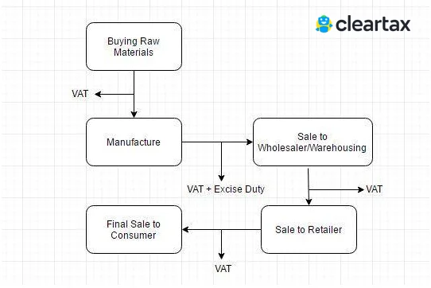

Under the GST regime, the tax is levied at every point of sale. In the case of intra-state sales, Central GST and State GST are charged. All the inter-state sales are chargeable to the Integrated GST.

Multi-stage

An item goes through multiple change-of-hands along its supply chain: Starting from manufacture until the final sale to the consumer.

Let us consider the following stages:

* Purchase of raw materials
* Production or manufacture
* Warehousing of finished goods
* Selling to wholesalers
* Sale of the product to the retailers
* Selling to the end consumers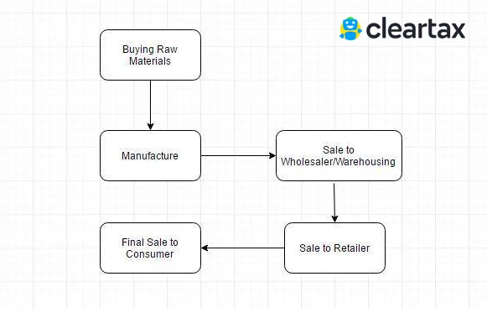

The Goods and Services Tax is levied on each of these stages making it a multi-stage tax.

**1.2 The Journey of GST in India**

The GST journey began in the year 2000 when a committee was set up to draft law. It took 17 years from then for the Law to evolve. In 2017, the GST Bill was passed in the Lok Sabha and Rajya Sabha. On 1st July 2017, the GST Law came into force.

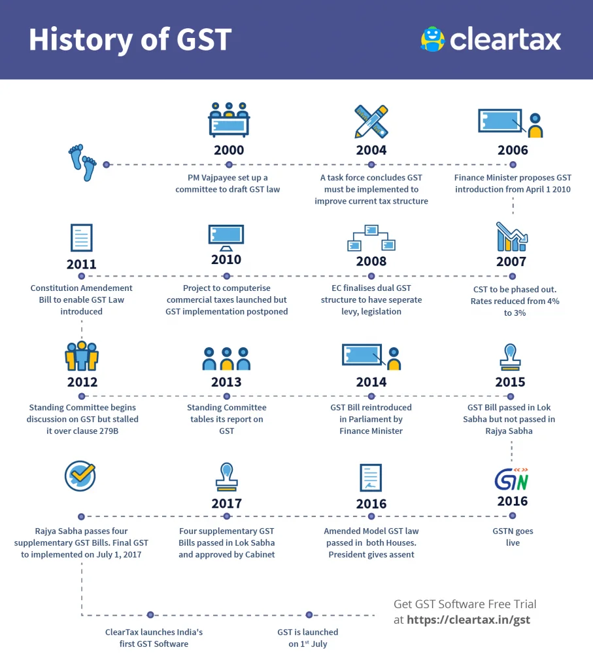

**1.3 Objectives Of GST**

**To achieve the ideology of ‘One Nation, One Tax’**

GST has replaced multiple indirect taxes, which were existing under the previous tax regime. The advantage of having one single tax means every state follows the same rate for a particular product or service. Tax administration is easier with the Central Government deciding the rates and policies. Common laws can be introduced, such as e-way bills for goods transport and e-invoicing for transaction reporting. Tax compliance is also better as taxpayers are not bogged down with multiple return forms and deadlines. Overall, it’s a unified system of indirect tax compliance.

**To subsume a majority of the indirect taxes in India**

India had several erstwhile indirect taxes such as service tax, Value Added Tax (VAT), Central Excise, etc., which used to be levied at multiple supply chain stages. Some taxes were governed by the states and some by the Centre. There was no unified and centralised tax on both goods and services. Hence, GST was introduced. Under GST, all the major indirect taxes were subsumed into one. It has greatly reduced the compliance burden on taxpayers and eased tax administration for the government.

**To eliminate the cascading effect of taxes**

One of the primary objectives of GST was to remove the cascading effect of taxes. Previously, due to different indirect tax laws, taxpayers could not set off the tax credits of one tax against the other. For example, the excise duties paid during manufacture could not be set off against the VAT payable during the sale. This led to a cascading effect of taxes. Under GST, the tax levy is only on the net value added at each stage of the supply chain. This has helped eliminate the cascading effect of taxes and contributed to the seamless flow of input tax credits across both goods and services.

**To curb tax evasion**

GST laws in India are far more stringent compared to any of the erstwhile indirect tax laws. Under GST, taxpayers can claim an input tax credit only on invoices uploaded by their respective suppliers. This way, the chances of claiming input tax credits on fake invoices are minimal. The introduction of e-invoicing has further reinforced this objective. Also, due to GST being a nationwide tax and having a centralised surveillance system, the clampdown on defaulters is quicker and far more efficient. Hence, GST has curbed tax evasion and minimised tax fraud from taking place to a large extent.

**To increase the taxpayer base**

GST has helped in widening the tax base in India. Previously, each of the tax laws had a different threshold limit for registration based on turnover. As GST is a consolidated tax levied on both goods and services both, it has increased tax-registered businesses. Besides, the stricter laws surrounding input tax credits have helped bring certain unorganised sectors under the tax net. For example, the construction industry in India.

**Online procedures for ease of doing business**

Previously, taxpayers faced a lot of hardships dealing with different tax authorities under each tax law. Besides, while return filing was online, most of the assessment and refund procedures took place offline. Now, GST procedures are carried out almost entirely online. Everything is done with a click of a button, from registration to return filing to refunds to e-way bill generation. It has contributed to the overall ease of doing business in India and simplified taxpayer compliance to a massive extent. The government also plans to introduce a centralised portal soon for all indirect tax compliance such as e-invoicing, e-way bills and GST return filing.

**An improved logistics and distribution system**

A single indirect tax system reduces the need for multiple documentation for the supply of goods. GST minimises transportation cycle times, improves supply chain and turnaround time, and leads to warehouse consolidation, among other benefits. With the e-way bill system under GST, the removal of interstate checkpoints is most beneficial to the sector in improving transit and destination efficiency. Ultimately, it helps in cutting down the high logistics and warehousing costs.

**To promote competitive pricing and increase consumption**

Introducing GST has also led to an increase in consumption and indirect tax revenues. Due to the cascading effect of taxes under the previous regime, the prices of goods in India were higher than in global markets. Even between states, the lower VAT rates in certain states led to an imbalance of purchases in these states. Having uniform GST rates have contributed to overall competitive pricing across India and on the global front. This has hence increased consumption and led to higher revenues, which has been another important objective achieved.

**1.4 Advantages Of GST**

GST has mainly removed the cascading effect on the sale of goods and services. Removal of the cascading effect has impacted the cost of goods. Since the GST regime eliminates the tax on tax, the cost of goods decreases.

Also, GST is mainly technologically driven. All the activities like registration, return filing, application for refund and response to notice needs to be done online on the GST portal, which accelerates the processes.

* Removing the cascading effect of tax
* Higher threshold for GST registration
* Composition scheme for small business
* Simpler online facilities for GST compliance
* Relatively lesser compliances under GST
* Defined treatment for e-commerce activities
* Increased efficiency in logistics
* Regulating the unorganized sectors

**1.5 The Components Of GST**

There are three taxes applicable under this system: [CGST, SGST & IGST](https://cleartax.in/s/what-is-sgst-cgst-igst).

* **CGST:** It is the tax collected by the Central Government on an intra-state sale (e.g., a transaction happening within Maharashtra)
* **SGST:** It is the tax collected by the state government on an intra-state sale (e.g., a transaction happening within Maharashtra)
* **IGST:** It is a tax collected by the Central Government for an inter-state sale (e.g., Maharashtra to Tamil Nadu)

In most cases, the tax structure under the new regime will be as follows: the components of GST?

|  |  |  |  |
| --- | --- | --- | --- |
| **Transaction** | **New Regime** | **Old Regime** | **Revenue Distribution** |
| Sale within the State | CGST + SGST | VAT + Central Excise/Service tax | Revenue will be shared equally between the Centre and the State |
| Sale to another State | IGST | Central Sales Tax + Excise/Service Tax | There will only be one type of tax (central) in case of inter-state sales. The Centre will then share the IGST revenue based on the destination of goods. |

**Types of GST and its Explanation**

As per the newly implemented tax system, there are 4 different types of GST:

1. Integrated Goods and Services Tax (IGST)
2. State Goods and Services Tax (SGST)
3. Central Goods and Services Tax (CGST)
4. Union Territory Goods and Services Tax (UTGST)

Additionally, the government has fixed different taxation rates under each, which will be applicable to the payment of tax for goods and/or services rendered.

**1. Integrated Goods and Services Tax or IGST**

The Integrated Goods and Services Tax or IGST is a tax under the GST regime that is applied on the interstate (between 2 states) supply of goods and/or services as well as on imports and exports. The IGST is governed by the IGST Act. Under IGST, the body responsible for collecting the taxes is the Central Government. After the collection of taxes, it is further divided among the respective states by the Central Government. For instance, if a trader from West Bengal has sold goods to a customer in Karnataka worth Rs.5,000, then IGST will be applicable as the transaction is an interstate transaction. If the [rate of GST](https://www.bankbazaar.com/tax/gst-rates.html) charged on the goods is 18%, the trader will charge Rs.5,900 for the goods. The IGST collected is Rs.900, which will be going to the Central Government.

**2. State Goods and Services Tax or SGST**

The State Goods and Services Tax or SGST is a tax under the GST regime that is applicable on intrastate (within the same state) transactions. In the case of an intrastate supply of goods and/or services, both State GST and Central GST are levied. However, the State GST or SGST is levied by the state on the goods and/or services that are purchased or sold within the state. It is governed by the SGST Act. The revenue earned through SGST is solely claimed by the respective state government. For instance, if a trader from West Bengal has sold goods to a customer in West Bengal worth Rs.5,000, then the GST applicable on the transaction will be partly CGST and partly SGST. If the rate of GST charged is 18%, it will be divided equally in the form of 9% CGST and 9% SGST. The total amount to be charged by the trader, in this case, will be Rs.5,900. Out of the revenue earned from GST

under the head of SGST, i.e. Rs.450, will go to the West Bengal state government in the form of SGST.

**3. Central Goods and Services Tax or CGST**

Just like State GST, the Central Goods and Services Tax of CGST is a tax under the GST regime that is applicable on intrastate (within the same state) transactions. The CGST is governed by the CGST Act. The revenue earned from CGST is collected by the Central Government. As mentioned in the above instance, if a trader from West Bengal has sold goods to a customer in West Bengal worth Rs.5,000, then the GST applicable on the transaction will be partly CGST and partly SGST. If the rate of GST charged is 18%, it will be divided equally in the form of 9% CGST and 9% SGST. The total amount to be charged by the trader, in this case, will be Rs.5,900. Out of the revenue earned from GST under the head of CGST, i.e. Rs.450, will go to the Central Government in the form of CGST.

**4. Union Territory Goods and Services Tax or UTGST**

The Union Territory Goods and Services Tax or UTGST is the counterpart of State Goods and Services Tax (SGST) which is levied on the supply of goods and/or services in the Union Territories (UTs) of India. The UTGST is applicable on the supply of goods and/or services in Andaman and Nicobar Islands, Chandigarh, Daman Diu, Dadra, and Nagar Haveli, and Lakshadweep. The UTGST is governed by the UTGST Act. The revenue earned from UTGST is collected by the Union Territory government. The UTGST is a replacement for the SGST in Union Territories. Thus, the UTGST will be levied in addition to the CGST in Union Territories.

Literature Review

1. G. Garg, 6 (2014)

analysed the impact of GST on Indian tax scenario. He tried to highlight the objectives of the proposed GST plan along with the possible challenges and opportunity that GST brings. He concluded that GST is the most logical steps towards the comprehensive indirect tax reform in our country since independence. GST is leviable on all supply of goods and provision of services as well combination thereof. All sectors of economy i.e the industry, business including Govt. departments and service sector shall have to bear impact of GST. All sections of economy viz., big, medium, small scale units, intermediaries, importers, exporters, traders, professionals and consumers shall be directly affected by GST. One of the biggest taxation reforms in India – the Goods and Service Tax (GST) is all set to integrate State economies and boost overall growth. GST will create a single, unified Indian market to make the economy stronger. Experts say that GST is likely to improve tax collections and Boost India’s economic development by breaking tax barriers between States and integrating India through a uniform tax rate. Under GST, the taxation burden will be divided equitably between manufacturing and services, through a lower tax rate by increasing the tax base and minimizing exemptions

1. B, MitraPriya, 27 (2017)

stated GST as a Game changer in Indian Economy. The paper showed that GST reduced complexity of various taxes and also removed cascading effect. Tax structure shown in paper in which various tax rates included. Impact on Tax incidence included various sectors such as Telecom, E- Commerce, Automobile, real estate, banking and consumer goods. Impact on input tax credit showed that there would be availability of cross credit utilization in CGST and SGST.

1. Sehrawat & Dhanda, 12 (2015)

conducted a study focused on advantages and challenges of GST faced by India in execution. They concluded that a simplified and transparent tax system was the need of Indian economy. Pointing out the various advantages they said that GST will provide India a world class tax structure and a seamless tax system but it will depend upon effectiveness of its implementation

1. Kapoor Kapil, 28 (2017)

critically examined GST implementation, models, mechanism, issues and challenges. Development stages GST in India studied in this paper. Exclusions

from GST which is petrol alcohal, tobacco, Diesel and some benefits such as simplicity, transparency, cascading effect, reduction in burden of tax tax revenue collection, economic growth and no tax for exporters are included in this paper. Challenges also studied in the paper. So the paper concluded that proper implementation of GST will lead to economic growth.

OBJECTIVES & SCOPE OF THE PROJECT

**3.1 Objectives of Project**

* To understand the e-filling procedure of GST
* To study the different forms which are used in filling of GST
* To understand different queries that individuals face while filling the GST

**3.2 Scope of study**

The scope of the study is the Goods & Service Tax only. It involves Tax calculation, GST liability calculation filling of return and different forms which are used in filling the return. There are in all

**Types of GST Returns and Due dates**

**GSTR-1**

GSTR-1 is the return to be furnished for reporting details of all outward supplies of goods and services made. In other words, it contains the invoices and debit-credit notes raised on the sales transactions for a tax period. GSTR-1 is to be filed by all normal taxpayers who are registered under GST, including casual taxable persons.  
  
Any amendments to sales invoices made, even pertaining to previous tax periods, should be reported in the [GSTR-1](https://cleartax.in/s/gstr-1) return by all the suppliers or sellers.  
  
The filing frequency of GSTR-1 is currently as follows:  
**(a) Monthly, by 11th* of every month-**If the business either has an annual aggregate turnover of more than Rs.5 crore or has not opted into the QRMP scheme.  
**(b) Quarterly, by 13th** of the month following every quarter-**If the business has opted into the QRMP scheme.  
  
*Till September 2018, the due date was the 10th of every month.  
**Till December 2020, was the end of the month succeeding the quarter.

**GSTR-2A**

GSTR-2A is a view-only dynamic GST return relevant for the recipient or buyer of goods and services. It contains the details of all inward supplies of goods and services i.e., purchases made from GST registered suppliers during a tax period.  
  
The data is auto-populated based on data filed by the corresponding suppliers in their GSTR-1 returns. Further, data filed in the Invoice Furnishing Facility (IFF) by the QRMP taxpayer, also get auto-filled.  
  
Since [GSTR-2A](https://cleartax.in/s/gstr-2a) is a read-only return, no action can be taken in it. However, it is referred by the buyers to claim an accurate Input Tax Credit (ITC) for every financial year, across multiple tax periods. In case any invoice is missing, the buyer can communicate with the seller to upload it in their GSTR-1 on a timely basis.  
  
It was used frequently for claiming ITC for every tax period until August 2020. Thereafter, the buyers must mostly refer to GSTR-2B, static return, to claim the input tax credit for every tax period.

**GSTR-2B**

GSTR-2B is again a view-only static GST return important for the recipient or buyer of goods and services. It is available every month, starting in August 2020 and contains constant ITC data for a period whenever checked back.  
  
ITC details will be covered from the date of filing GSTR-1 for the preceding month (M-1) up to the date of filing GSTR-1 for the current month (M). The return is made available on the 12th of every month, giving sufficient time before filing GSTR-3B, where the ITC is declared.  
  
[GSTR-2B](https://cleartax.in/s/gstr-2b) provides action to be taken against every invoice reported, such as to be reversed, ineligible, subject to reverse charge, references to the table numbers in GSTR-3B.

**GSTR-2**

[GSTR-2](https://cleartax.in/s/gstr2) is currently a suspended GST return, that applied to registered buyers to report the inward supplies of goods and services, i.e. the purchases made during a tax period.  
  
The details in the GSTR-2 return had to be auto-populated from the GSTR-2A. Unlike GSTR-2A, the GSTR-2 return can be edited. GSTR-2 is to be filed by all normal taxpayers registered under GST. However, the filing of the same has been suspended ever since September 2017.

**GSTR-3**

[GSTR-3](https://cleartax.in/s/gst-return-gstr3) is again currently a suspended GST return. It was a monthly summary return for furnishing summarized details of all outward supplies made, inward supplies received and input tax credit claimed, along with details of the tax liability and taxes paid.  
  
This return would have got auto-generated on the basis of the GSTR-1 and GSTR-2 returns filed. GSTR-3 is to be filed by all normal taxpayers registered under GST, however, the filing of the same has been suspended  
ever since September 2017.

**GSTR-3B**

[GSTR-3B](https://cleartax.in/s/gstr-3b) is a monthly self-declaration to be filed, for furnishing summarised details of all outward supplies made, input tax credit claimed, tax liability ascertained and taxes paid.  
  
GSTR-3B is to be filed by all normal taxpayers registered under GST. The sales and input tax credit details must be reconciled with GSTR-1 and GSTR-2B every tax period before filing GSTR-3B. GST reconciliation is crucial to identify mismatches in data, that may lead to GST notices in future or suspension of GST registration as well.

The filing frequency of GSTR-3B is currently as follows:  
**(a) Monthly, 20th* of every month-** For taxpayers with an aggregate turnover in the previous financial year of more than Rs.5 crore or have been otherwise eligible but still opted out of the QRMP scheme.  
**(b) Quarterly, 22nd of the month following the quarter for ‘X’** category of States and 24th of the month following the quarter for ‘Y’** category of States-**For the taxpayers with aggregate turnover equal to or below Rs 5 crore, eligible and remain opted into the QRMP scheme.  
  
* Effective from January 2021 tax period onwards. Previously, was as follows-  
(i) Was staggered as 20th (turnover of previous FY was more than Rs.5 crore), 22nd and 24th (turnover of previous FY was up to Rs.5 crore, for ‘X’ and ‘Y’ category of States) of every month, from January 2020 till December 2020.  
(ii) Was 20th of every month till December 2019.  
  
** **‘X’ category States/UT –**Chhattisgarh, Madhya Pradesh, Gujarat, Maharashtra, Karnataka, Goa, Kerala, Tamil Nadu, Telangana or Andhra Pradesh or the Union territories of Daman and Diu and Dadra and Nagar Haveli, Puducherry, Andaman and Nicobar Islands and Lakshadweep.  
**‘Y’ category States/UT-** Himachal Pradesh, Punjab, Uttarakhand, Haryana, Rajasthan, Uttar Pradesh, Bihar, Sikkim, Arunachal Pradesh, Nagaland, Manipur, Mizoram, Tripura, Meghalaya, Assam, West Bengal, Jharkhand or Odisha or the Union Territories of Jammu and Kashmir, Ladakh, Chandigarh and New Delhi.

**GSTR-4**

[GSTR-4](https://cleartax.in/s/gstr4-composition-dealer-gst-return) is the annual return that was to be filed by the composition taxable persons under GST, by 30th April of the year following the relevant financial year. It has replaced the erstwhile GSTR-9A (annual return) from FY 2019-20 onwards.  
  
Prior to FY 2019-20, this return had to be filed on a quarterly basis. Thereafter, a simple challan in form [CMP-08](https://cleartax.in/s/form-cmp-08) filed by 18th of the month succeeding every quarter replaced it.  
  
The composition scheme is a system in which taxpayers dealing with goods and having a turnover up to Rs.1.5 crores can opt into and pay taxes at a fixed rate on the turnover declared. Further, the service providers can avail a similar scheme CGST (Rate) Notification 2/2019 dated 7th March 2019 if turnover is up to Rs.50 lakh.

**GSTR-5**

[GSTR-5](https://cleartax.in/s/gst-return-gstr5) is the return to be filed by non-resident foreign taxpayers, who are registered under GST and carry out business transactions in India.  
  
The return contains details of all outward supplies made, inward supplies received, credit/debit notes, tax liability and taxes paid.   
  
The GSTR-5 return is to be filed monthly by the 20th of each month under GSTIN that the taxpayer is registered in India.

**GSTR-5A**

GSTR-5A refers to a summary return for reporting the outward taxable supplies and tax payable by Online Information and Database Access or Retrieval Services (OIDAR) provider under GST.  
  
The due date to file GSTR-5A is the 20th of every month.

**GSTR-6**

[GSTR-6](https://cleartax.in/s/gstr-6-gst-return) is a monthly return to be filed by an Input Service Distributor (ISD).  
  
It will contain details of input tax credit received and distributed by the ISD. It will further contain details of all documents issued for the distribution of input credit and the manner of distribution.  
  
The due date to file GSTR-6 is the 13th of every month.

**GSTR-7**

[GSTR-7](https://cleartax.in/s/gstr-7-gst-return) is a monthly return to be filed by persons required to deduct TDS (Tax deducted at source) under GST.  
  
This return will contain details of TDS deducted, the TDS liability payable and paid and TDS refund claimed if any.  
  
The due date to file GSTR-7 is the 10th of every month.

**GSTR-8**

[GSTR-8](https://cleartax.in/s/gstr-8-gst-return) is a monthly return to be filed by e-commerce operators registered under the GST who are required to collect tax at source (TCS).  
  
It contains details of all supplies made through the e-commerce platform, and the TCS collected on the same.  
  
The GSTR-8 return is to be filed on a monthly basis by the 10th of every month.

**GSTR-9**

[GSTR-9](https://cleartax.in/s/gstr-9-annual-return) is the annual return to be filed by taxpayers registered under GST. It is due by 31st December of the year following the relevant financial year, as per the GST law.  
  
It contains the details of all outward supplies made, inward supplies received during the relevant financial year under different tax heads i.e. CGST, SGST & IGST and a summary value of supplies reported under every HSN code, along with details of taxes payable and paid.  
  
It is a consolidation of all the monthly or quarterly returns (GSTR-1, GSTR-2A, GSTR-3B) filed during that financial year. GSTR-9 is required to be filed by all taxpayers registered under GST.  
  
However, there are few exceptions such as taxpayers who have opted for the composition scheme, casual taxable persons, input service distributors, non-resident taxable persons and persons paying [TDS](https://cleartax.in/s/tds-under-goods-and-service-tax) under section 51 of the CGST Act.  
  
**Note:**As per the CGST notification no. 47/2019, later amended, the annual return under GST for taxpayers having an aggregate turnover that does not exceed Rs.2 crore has been made optional for FY 2017-18, FY 2018-19 and FY 2019-20.

**GSTR-9A**

[GSTR-9A](https://cleartax.in/s/gstr-9a) is currently a suspended annual return earlier required to be filed by composition taxpayers. It had a consolidation of all the quarterly returns filed during that financial year.  
  
Ever since GSTR-4 (annual return) was introduced from FY 2019-20, this return stands scrapped. Prior to that, GSTR-9A filing for composition taxpayers had been waived off for FY 2017-18 and FY 2018-19.

**GSTR-9C**

[GSTR-9C](https://cleartax.in/s/gst-reconciliation-statement-gstr-9c) is the reconciliation statement to be filed by all taxpayers registered under GST whose turnover exceeds Rs.2 crore in a financial year, as per the GST law.  
  
It must be certified by a Chartered Accountant/Cost & Management Accountant after conducting a thorough GST audit of the books of accounts and comparing the figures with the GSTR-9.  
  
The deadline to file this statement is the same as the due date prescribed for GSTR-9, i.e., 31st December of the year following the relevant financial year.  
  
GSTR-9C is to be filed for every [GSTIN](https://cleartax.in/s/gst-number-search), hence, one [PAN](https://cleartax.in/s/pan-card) can have multiple GSTR-9C forms being filed.  
  
As per the Union Budget 2021 outcome, the GST audit requirement by professionals such as CAs and CMAs has been removed from the GST law. Sections 35 and 44 were amended for this but yet to be notified by CBIC. Accordingly, GSTR-9 needs to be filed on the GST portal by taxpayers on a self-certification basis, completely removing the requirement for GSTR-9C. However, the financial year and date of applicability of this removal are yet to be clarified by the government.  
  
**Note:**As per the CBIC notification 16/2020, which was further amended, GSTR-9C is waived off for the taxpayers with an aggregate turnover of more than Rs.5 crore for the financial year 2018-19 and 2019-20.

**GSTR-10**

[GSTR-10](https://cleartax.in/s/gstr-10-gst-final-return) is to be filed by a taxable person whose registration has been cancelled or surrendered. This return is also called a final return and has to be filed within three months from the date of cancellation or cancellation order, whichever is earlier.

**GSTR-11**

[GSTR-11](https://cleartax.in/s/gstr-11-uin-gst-return) is the return to be filed by persons who have been issued a Unique Identity Number (UIN) in order to get a refund under GST for the goods and services purchased by them in India. UIN is a classification made for foreign diplomatic missions and embassies not liable to tax in India, for the purpose of getting a refund of taxes. GSTR-11 will contain details of inward supplies received and refund claimed.

RESEARCH METHODOLOGY

Data are the bricks with which the researcher has to make a house. While the quality of research findings depends on data, the adequacy of appropriate data in turn depends upon proper method of data collection. This project is based on primary as well as secondary data. But primary data collection had limitations due to matter of confidentiality. And the secondary data is where I had done some changes in primary data.

Primary Data

Data which are collected fresh and for the first time and thus happens to be original in character. Primary data are gathered for specific purpose.

Secondary Data

Data that Collected from official website of GST . For the purpose of our study we collected both the data

THEORETICAL BACKGROUND

**5.1 GST**

**Goods and Services Tax** (**GST**) is an [indirect tax](https://en.wikipedia.org/wiki/Indirect_tax) (or [consumption tax](https://en.wikipedia.org/wiki/Consumption_tax)) used in [India](https://en.wikipedia.org/wiki/India) on the supply of goods and services. It is a comprehensive, multistage, destination-based tax: comprehensive because it has subsumed almost all the indirect taxes except a few state taxes. Multi-staged as it is, the GST is imposed at every step in the production process, but is meant to be refunded to all parties in the various stages of production other than the final consumer and as a destination-based tax, it is collected from point of consumption and not point of origin like previous taxes.

**5.2 What is GST?**

GST is known as the Goods and Services Tax. It is an indirect tax which has replaced many indirect taxes in India such as the excise duty, VAT, services tax, etc. The Goods and Service Tax Act was passed in the Parliament on 29th March 2017 and came into effect on 1st July 2017.

In other words,[Goodsand Service Tax (GST)](https://cleartax.in/s/gst-full-form-meaning) is levied on the supply of goods and services. Goods and Services Tax Law in India is a**comprehensive, multi-stage, destination-based tax**that is levied on every**value addition.** GST is a single domestic indirect tax law for the entire country.

**5.3 Who should pay GST?**

Now let us see who all are liable to pay GST. The following categories of persons will be liable to pay GST:

1. Persons registered under GST and making taxable supplies under GST.
2. Persons registered under GST required to make payment of tax under reverse charge mechanism.
3. E-Commerce operators registered under GST and through whom certain categories of notified supplies are made.
4. Persons registered under GST and required to deduct Tax (TDS)
5. E-Commerce Operators registered under GST and required to collect tax (TCS)

**5.4 Taxpayers and GST Return Slab Rates**

Goods and services are divided into five different tax slabs for collection of tax: 0%, 5%, 12%, 18% and 28%. However, [petroleum products](https://en.wikipedia.org/wiki/Petroleum_products), [alcoholic drinks](https://en.wikipedia.org/wiki/Alcoholic_drinks), and [electricity](https://en.wikipedia.org/wiki/Electricity) are not taxed under GST and instead are taxed separately by the individual [state governments](https://en.wikipedia.org/wiki/State_governments_of_India), as per the previous tax system. There is a special rate of 0.25% on rough precious and semi-precious stones and 3% on [gold](https://en.wikipedia.org/wiki/Gold). In addition a [cess](https://en.wikipedia.org/wiki/Cess) of 22% or other rates on top of 28% GST applies on few items like aerated drinks, [luxury cars](https://en.wikipedia.org/wiki/Luxury_cars) and tobacco products. Pre-GST, the statutory tax rate for most goods was about 26.5%, Post-GST, most goods are expected to be in the 18% tax range.

**Benefits of E-filling GSTR**

* **Accuracy**: E-Filing software with built-in validations and electronic connectivity to  
  GSTD are seamless and help minimize errors. Paper based filing with self calculations can be prone to error. Also, when any paper based form is transferred to electronic system, there is always a possibility of human error in data entry.
* **Fast Processing**: The acknowledgment of GSTR submission is fast and the refunds are processed faster by the GST Department for E-Filed GSTRs.
* **No Time Circumscription**: You can file anytime, anywhere. E-Filing is available 24 hours a day, seven days a week, so taxpayers may always file at their own convenience.
* **More Secure than Paper based filing**: E-filing is safer than paper based filing. With paper based filing your confidential identity information is lying in files and can be passed from person to person
* **Data Access in Future**: Most of the paid E-filing software applications store your data in a secure manner and allow you to access it whenever you are ready to file subsequent returns.

**Saving environment**: E-Filing is environment friendly. You just need to print no or at most one page instead of multiple copies of multiple pages that is required in case of paper based filing

**5.5 GST Calculation**

The new Goods and Services Tax (GST) has changed the way businesses use to bill their clients and or customers.

**Step 1:** The first step is to find the exact slab rate for the goods or services under the [GST](https://timesofindia.indiatimes.com/business/gst) Act. To find [GST Rate](https://timesofindia.indiatimes.com/topic/gst-rates), you will have to determine the type of supply item, i.e., whether is it a good or a service. If the supply is a good, find the HSN Code and if the transaction involves the supply of a service, then find the SAC Code.   
Once you know the HSN or SAC Code, then find out under which slab of GST tax rate the supply fits into. The GST Council has created 5 different slab rates at NIL/0%, 5%, 12%, 18% and 28% for both goods and services.

**Step 2:** Once you know the GST rate, next find out the applicability of IGST or CGST and SGST. To do so, you need to determine the place of supply first. Mostly, the place where the supply of goods or services was done would be the address where the goods or the service was provided. But in case of e-commerce or OIDAR services, the determination of the place of supply is a more complex issue.  
**Step 3:** Under GST rule, the supplier of the goods or service can collect tax from the recipient and remit the same to the government. However, there are some services like 'reverse charge services', where the recipient is made liable for payment of GST.  
**Step 4:**According to new GST rules, suppliers must maintain extensive accounts, records and file 3 GST forms in a month. However, small businesses having a turnover of less than Rs 75 lakhs, can enrol under the GST Composition Scheme and pay a flat GST based on their aggregate turnover. You should check whether your supplier is enrolled under GST Composition Scheme or not.  
**Step 5:**Next is to find out the type of transactions, for example - Business to Business; Business to Consumer where the value of supply is more than Rs 2.5 lakhs; or Business to Consumer where the value of supply is less than Rs 2.5 lakhs.

1. **to compute GST return?**

This can be done by subtracting the comprehensive GST have paid on your purchases and expenses (available on the box 14 on your return) from the holistic GST have received from sales and income (available on the box 10 on your return).

1. **How many GST returns are available to claim?**  
   A regular business can file either monthly returns or annual returns under GST. The total of this comes to around 26 returns in a single financial year.
2. **How to calculate late fees for GST?**  
   There is a penalty of 5% of the balance owing plus the 1% of your balance owing for each full month your return is late, subject to a maximum of 12-month time-period.
3. **Is GST computed on MRP?**  
   Yes, MRP or maximum retail price is inclusive of all taxes including GST too. No retailer can charge GST over and above the MRP.

* .

**5.6What are the New Compliances Under GST?**

Apart from online filing of the GST returns, the GST regime has introduced several new systems along with it.

**e-Way Bills**

GST introduced a centralised system of waybills by the introduction of “[E-way bills”](https://cleartax.in/s/gst-eway-bill-software). This system was launched on 1st April 2018 for inter-state movement of goods and on 15th April 2018 for intra-state movement of goods in a staggered manner.

Under the e-way bill system, manufacturers, traders and transporters can generate e-way bills for the goods transported from the place of its origin to its destination on a common portal with ease. Tax authorities are also benefited as this system has reduced time at check -posts and helps reduce tax evasion.

**E-invoicing**

The [e-invoicing system](https://cleartax.in/s/e-invoicing-enterprise-software) was made applicable from 1st October 2020 for businesses with an annual aggregate turnover of more than Rs.500 crore in any preceding financial years (from 2017-18). Further, from 1st January 2021, this system was extended to those with an annual aggregate t urnover of more than Rs.100 crore.

These businesses must obtain a unique invoice reference number for every business-to-business invoice by uploading on the GSTN’s invoice registration portal. The portal verifies the correctness and genuineness of the invoice. Thereafter, it authorises using the digital signature along with a QR code.

e-Invoicing allows interoperability of invoices and helps reduce data entry errors. It is designed to pass the invoice information directly from the IRP to the GST portal and the e-way bill portal. It will, therefore, eliminate the requirement for manual data entry while filing GSTR-1 and helps in the generation of e-way bills too.

**THEORETICAL BACKGROUND OF E-FILLING AND GST RETURN**

Introduction&Definition of e-filling

GST return filing in India is mandatory for all the entities that have a valid GST registration irrespective of the business activity or the sales or the profitability during the period of filing the returns. Hence, even a dormant business that has a valid GST registration must file the GST returns.

GST return is a document that contains the details of all the income or the expenses that a taxpayer is required to file with the tax administrative authorities.

An individual taxpayer filing the GST returns has to file 4 forms for filing the GST returns such as the returns for the supplies, returns for the purchases made, monthly returns, and the annual returns

The businesses registered under GST have to file returns monthly, quarterly and annualy based on the category of business through the Government of India's [GST portal](https://www.bankbazaar.com/tax/guide-on-gst-portal.html). They have to provide the details of the sales and purchases of goods and services along with the tax collected and paid.

Implementation of a comprehensive Income Tax system like [GST](https://www.bankbazaar.com/tax/gst.html) in India will ensure that taxpayer services such as registration, returns, and compliance are transparent and straightforward. Individual taxpayers will be using 4 forms for filing their GST returns such as the return for supplies, return for purchases, monthly returns, and annual return. Small taxpayers who have opted for a composition scheme will have to file quarterly returns. All filing of returns will be done online.

Objectives

* To know E-filling Process GST Return
* To assess the return’s perception, awareness towards e-filling of GST returns.

DATA ANALYSIS

**FOR FILING, GST RETURNS ONLINE BELOW LISTED ARE THE STEPS.**

**Step 1:** Once you log in to the GST portal, click on the "Services" tab on the GST dashboard.  
  
**Step 2:**Then, in the "Services" menu, click on the "Returns Dashboard."

[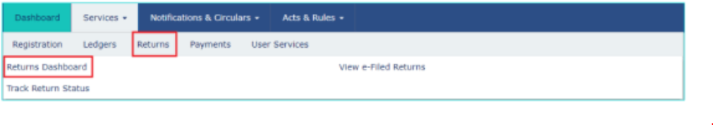](https://lh6.googleusercontent.com/0pdqu3YqzyMBJ4h_Qn1_NaQqJq38yNJaXUI1dIA8lGYKbyNTlnKAu3YyEWvPlWYXuJNFVLeEY6AxIyJw-mIyFp_QtOCZ5uKNtOD3BF0iBIpx_xrrRjmrRpB2vltvV4DzhVREpCPc)Return Dashboard

**Step 3:**Later**,**select the "Financial Year" and the "Return Filing Period" and then click on "Search."

[](https://lh6.googleusercontent.com/5iGXwfGxITvDO1LksCGZHaj4xwoqA6JYyyvDyRy7D90ojxHOL1D4T7AQs2Q8ReHO89TYDUfm4cvR5t3qoRBCVm0zG7OnuoI1dckeRBg67UjurVnHpzr0LTFk2f2LfOz4LUDtYYzn)Select the "Financial Year" and the "Return Filing Period"

**Step 4:** On the screen, separate tiles of all the GST returns that can be filed will be displayed. By clicking on either the options "Prepare Online" or "Prepare Offline" button in the corresponding tile, select the GST to return you want to file.

[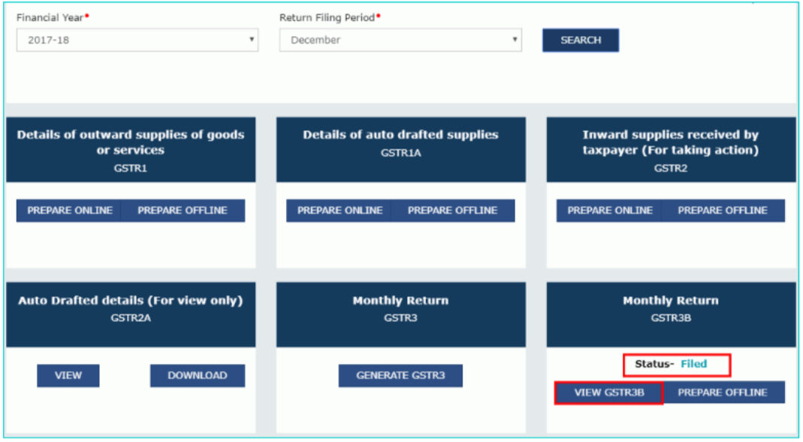](https://lh6.googleusercontent.com/ldrXCzCsn-vdfiJtLtpitrciktVsCW-150Wr83HIPqUydMicL0nsqF48J0qtgQPOzdkXpYvps4TZMs-5-DHKxDJNuHhcveQmXkCSgDH5p-kIt1NJBEXQvAb_L1SWImiW70NiyoN3) Select the GST to return you want to file

**Step 5:**You can either file your GST returns online by clicking the "Prepare Online" button or clicking the "Prepare Offline" button using  [GST offline tools utility](https://www.gst.gov.in/quicklinks/downloads-utilities).  
  
**Step 6:**Enter the required details in the online GSTR form or the offline GSTR tool. By clicking on the "Prepare Offline" button, please note that you need to upload the filled offline utility form.  
  
**Step 7:**Once all the details in the GST Return form are entered, you need to save the details and submit it.  
  
**Step 8:** Later, you can make the GST payment online using the appropriate challan after submitting all the relevant information.  
  
**Step 9:** On filing successfully, the message of "Filing Successful" will be displayed with the ARN(Acknowledgement Reference Number). For future reference, note the ARN.

[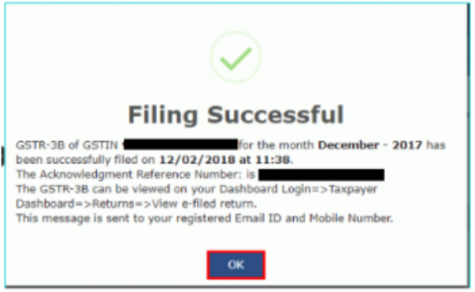](https://lh4.googleusercontent.com/MSUN5YIcffGF6Jy9Mu95jafUcCLOxTzehlpDsDLRz0z7_wOC582njO9wSjLQ_-p0-w7yOa2uxTSwg-pqpqYCE0H-gJD1wFQelwP9ii1rWORE1MNuJu3hoA3Ql7kJJUvBgMGxprmU)"Filing Successful" Message

**Step 10:** By clicking on Services > Returns > Returns Dashboard, you can check the return filing status. You need to select the Financial Year and return filing period and click "Search." All the relevant GSTR forms will be displayed along with their filing status.

[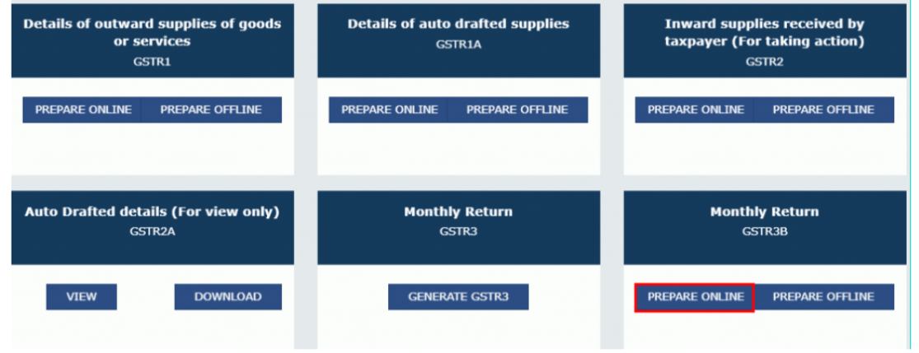](https://lh6.googleusercontent.com/-XoisoVorh6JDEgeKv3P-IsUeaMwbBRXBKIm2IzkQPYHz20aq9a8XFSoTUYLKcUAuBR7vIniw6lf3cfLkFOB3bxKEeZgf7LGBM_GkOSBWHu0owepEcT4de0T0okyPYWgLqHMNgJI)All the relevant GSTR forms are displayed along with their filing status

### How to File GSTR 1, 2, and 3 Returns?

Goods and Services Tax return filing has to be done every month/quarter by a registered taxpayer. This is a record of Outward and Inward supply done during the month/quarter, and tax paid/payable by the Supplier. Besides this, the taxpayer also needs to file Annual Returns.

[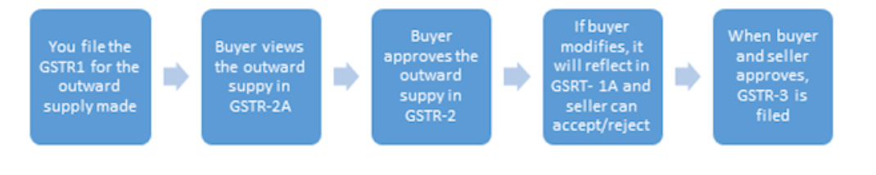](https://lh5.googleusercontent.com/4eQVlgg4Kozi9MuGpawcQskfXVtiOdX5-HGrblz3RK18KNrsmM3pxD2VTJqB1GzbEN2zEOeoXQTVKY3e6KJ6j9poDO39594JNGgb9D8JWcn6ZUpzvsH0ohCwrxlbCgIUhAYPGIFq)*Filing Returns*

The Goods and Service Tax Network will store information of all GST registered sellers and buyers, combine the submitted details, and maintain registers for future reference. Companies have to file 3 monthly returns every 3 months and one annual return in a financial year (37 returns in total). GSTN has launched a simple excel based template to make the filing of returns easier for businesses. This excel workbook can be downloaded from the GST common portal free of charge. Taxpayers can use this template to collate invoice data regularly. The details of inward and outward supplies can be uploaded on the GST portal on or before the due date. The data preparation can be done offline. Only while uploading the prepared file on the GST portal will the taxpayer need the Internet

**How to check GST Returns Status?**

The official GST Login Portal allows you to check the status of your GST Returns. There are 3 different methods for the same. The methods are as follows:

* Tracking the status using the ‘Return Filing Period’ option
* Tracking the status using the ‘ARN’ option
* Tracking the status using the ‘Status’ option

**Tracking the status using the ‘Return Filing Period’ option**

Step 1: Use your credentials to log in to the online GST portal at https://www.gst.gov.in/.

Step 2: Click on the ‘Services’ tab from the top menu.

Step 3: Navigate to ‘Track Return Status’ under the ‘Returns’ option.

Step 4: Select the ’Return Filing Period’ option.

Step 5: In the next page, select the financial year and the return filing period from the respective drop-down boxes.

Step 6: Click on the ‘Search’ button and the status of the GST Return will be displayed on your screen.

**Tracking the status using the ‘ARN’ option**

* **Step 1:** Use your credentials to log in to the online GST portal at https://www.gst.gov.in/.
* **Step 2:** Click on the ‘Services’ tab from the top menu.
* **Step 3:** Navigate to ‘Track Return Status’ under the ‘Returns’ option.
* **Step 4:** Select the ’ARN’ option.
* **Step 5:** Enter the ARN in the field provided.
* **Step 6:** Click on the ‘Search’ button and the status of the GST Return will be displayed on your screen

**Tracking the status using the ‘Status’ option**

Step 1: Use your credentials to log in to the online GST portal at https://www.gst.gov.in/.

Step 2: Click on the ‘Services’ tab from the top menu.

Step 3: Navigate to ‘Track Return Status’ under the ‘Returns’ option.

Step 4: Select the ’Status’ option.

Step 5: Select the Status of Return that you are looking for from the drop-down box.

Step 6: Click on the ‘Search’ button and the status of the GST Return will be displayed on your screen.

**How to Download GST Returns?**

You can download your GST Returns from the official GST Portal. You can follow the steps mentioned below to download your GST Returns:

* **Step 1:** Use your credentials to log in to the online GST portal at **https://www.gst.gov.in/**.
* **Step 2:** Click on the ‘Services’ tab from the top menu.
* **Step 3:** Navigate to ‘Returns Dashboard’ under the ‘Returns’ option.
* **Step 4:** In the next page, select the financial year and the return filing period from the respective drop-down boxes.
* **Step 5:** Click on the ‘Search’ button and select the GTR that you want to download.
* **Step 6:** Click on the ‘Prepare Offline’ button under the selected GSTR.
* **Step 7:** Navigate to the ‘Download’ option and click on ‘Generate File’.
* **Step 8:** In general, the request for the generation of the file takes around 20 minutes.
* **Step 9:** Once the file is generated, a download link will be generated. Click on the ‘Click Here’ option to download the ZIP file containing your GST Returns.

Data Analysis of GST

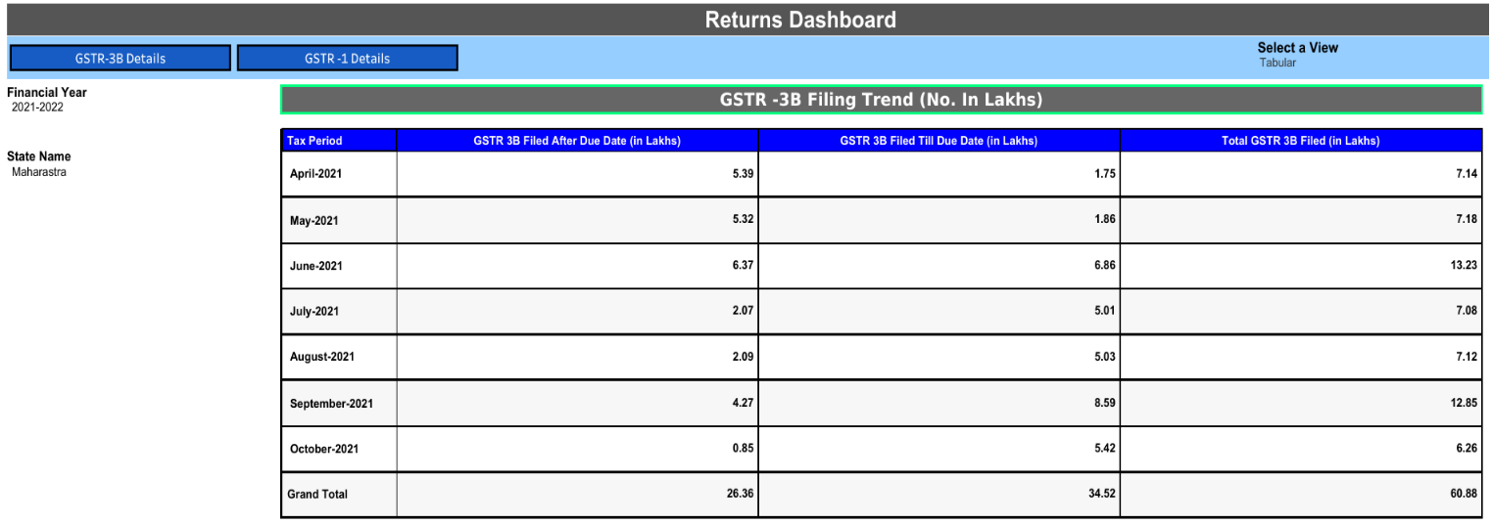

Fig.1.5 GSTR- 3B Filing (No. in Lakhs)

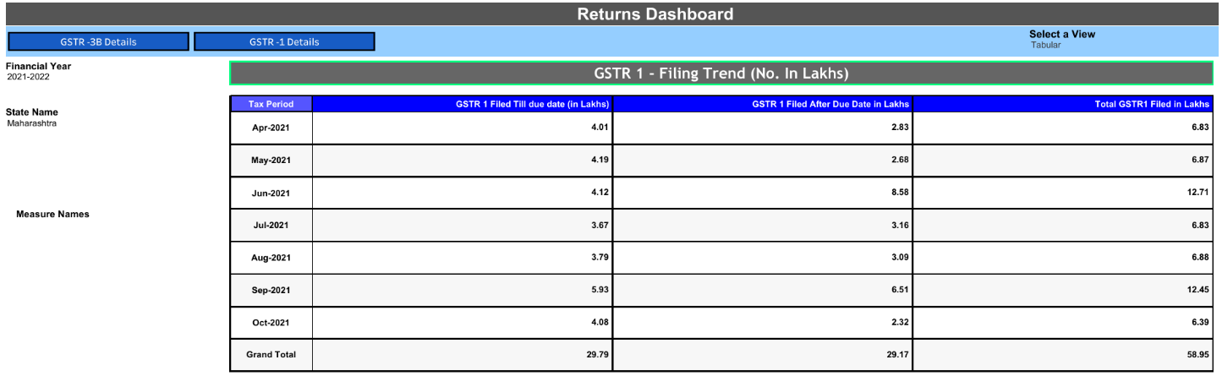

Fig.1.6 GSTR 1 – Filing Trend (No. In Lakhs)

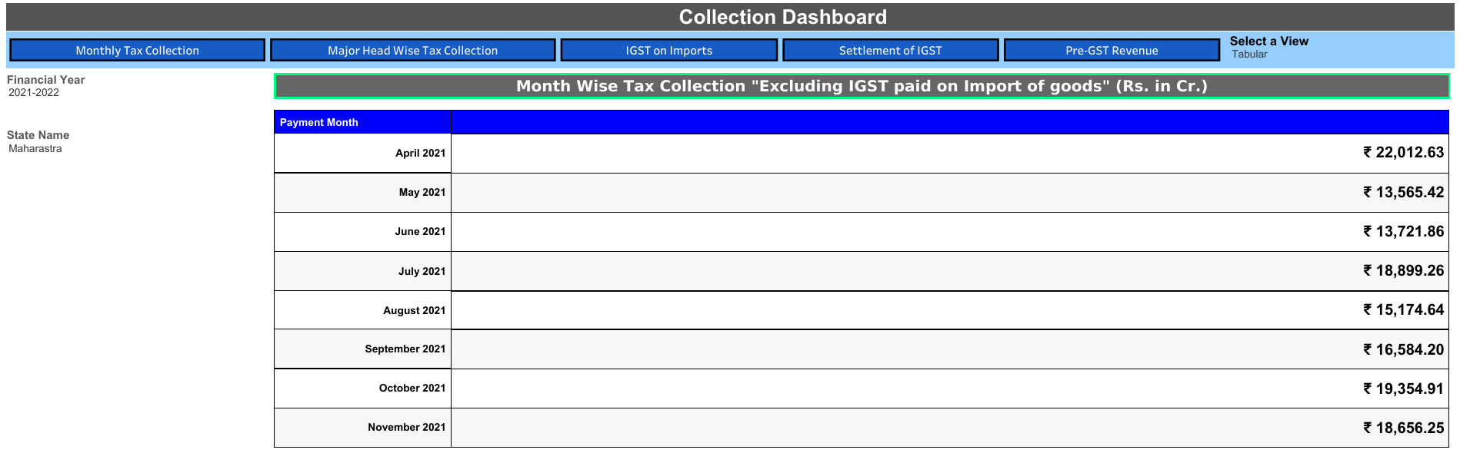

Fig.1.7 monthwise Tax Collection “Excluding IGST paid on Import of goods”

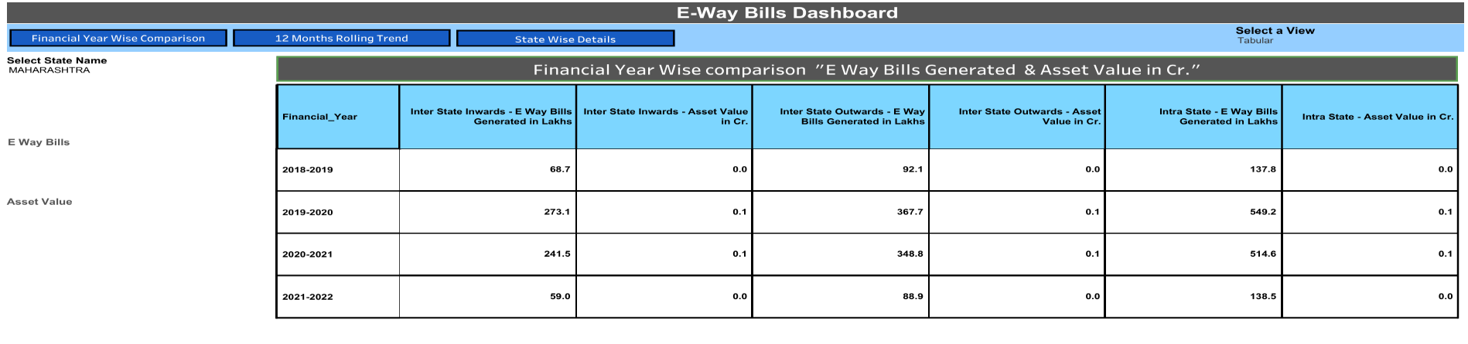Fig.1.8 Financial Year Wise comparison “E way bills Generated & Asset Value in cr.”

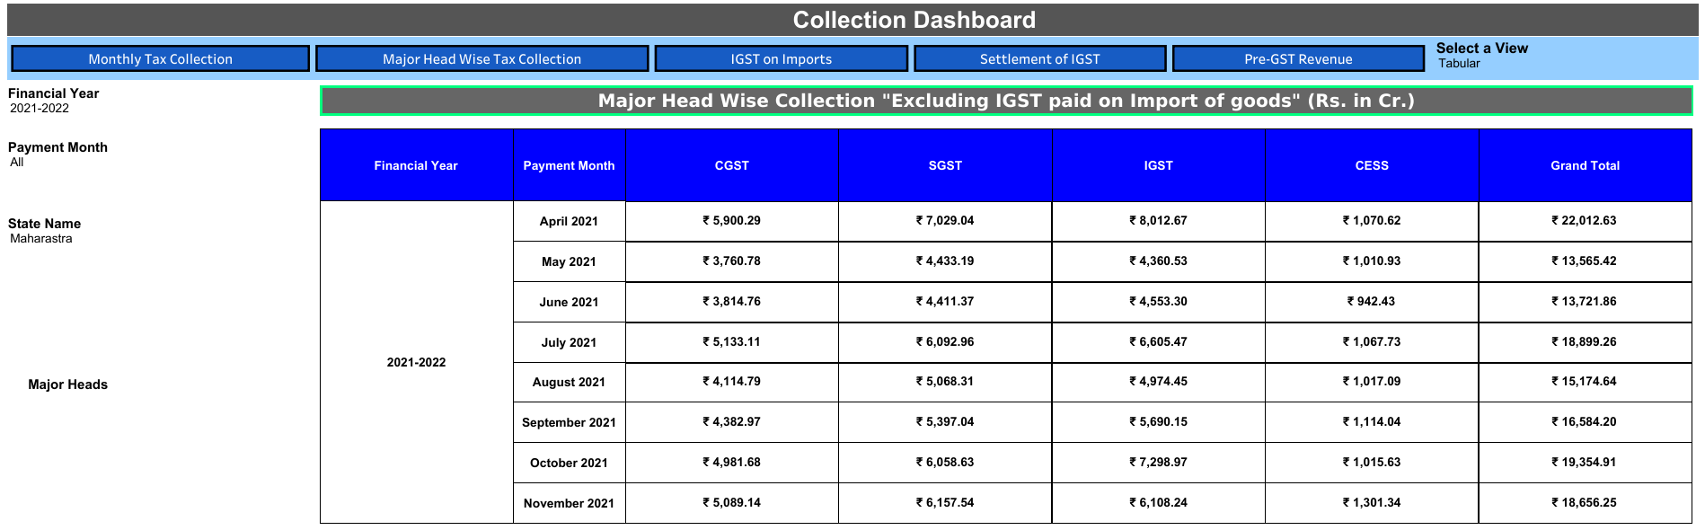

Fig.1.9 major head wise collection “excluding igst paid on import of goods”

GST Registration

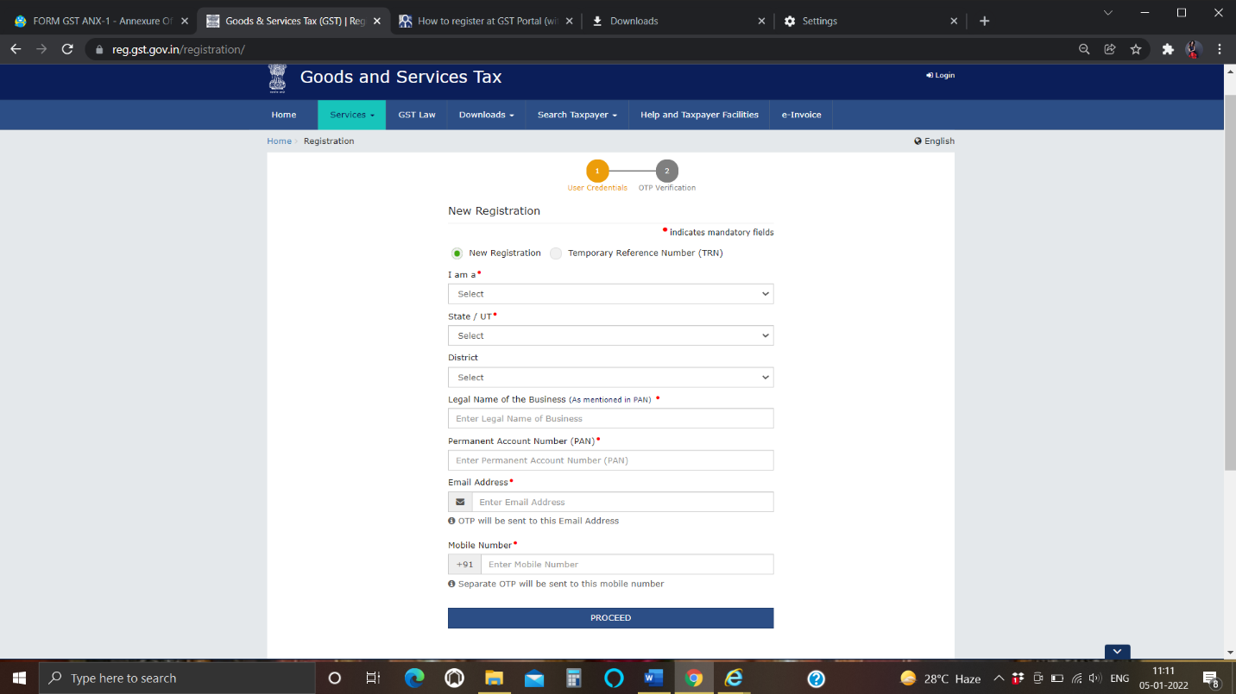

CONCLUSION

**CONCLUSION**

Implementation of GST is one of the best decision taken by the Indian government. For the same reason, July 1 was celebrated as Financial Independence day in India when all the Members of Parliament attended the function in Parliament House. The transition to the GST regime which is accepted by 159 countries would not be easy. Confusions and complexities were expected and will happen. India, at some point, had to comply with such regime. Though the structure might not be a perfect one but once in place, such a tax structure will make India a better economy favourable for foreign investments. Until now India was a union of 29 small tax economies and 7 union territories with different levies unique to each state. It is a much accepted and appreciated regime

because it does away with multiple tax rates by Centre and States. And if you are doing any kind of business then you should register for GST as it is not only going to help Indian government but will help you also to track your business weekly as in GST you have to make your business activity statement each week.

FINDINGS

FINDINGS

1. The company is more comfortable in filing the returns of residential individuals.
2. Many times it is observed that, clients are not providing proper documentations
3. Clients are facing many queries regarding to filing of returns because of the wrong perception in the minds of clients.
4. Clients are not interested in declaring their actual income.
5. The use of E-filing is increasing day by day as it is easy and convenient.

SUGGESTIONS/RECOMMENDATIONS

SUGGESTIONS/RECOMMENDATIONS

1. Government of India make a clear cut decision in rates of GST

2. Government of India must reduce the various slabs 5 into 3 or two

3. Finance ministry want to make various awareness camps

4. Individual tax payers want to know their roles.

5. Make the procedure of e-filing more easy so that everyone will able to file the returns online and the number of people using e-filing will go on increasing.

6. Professionals should make their clients aware about the procedure of e-filing so that clients will understand what exactly professionals are doing.

7. People who are filing their return on their own should file it through official site of Goods & Service Tax ([www.gst.gov.in](http://www.gst.gov.in) )

BIBLIOGRAPHY

BIBLIOGRAPHY

1. Published Book

a)Madhukar Hiregange’s Practical Guide to E-way Bill under GST by CA N Raghunandan and CA Narendra Nimmala, Bloomsbury Professional India

2. World Wide Web

a) <https://www.gst.gov.in>

b) <https://www.gst.gov.in/dashboard>

c) <https://gstcouncil.gov.in>

d) <https://cleartax.in>

e) <https://cleartax.in/s/gst-monthly-tax-itc-summary>

ANNEXURE

E-filing GST Portal

